# Experiment No: 16

**Aim**

Implementation of Replica Set on MongoDB

# CO5

Apply CRUD operations and retrieve data in a NoSQL environment.

# Procedure

1. Create Replica Set

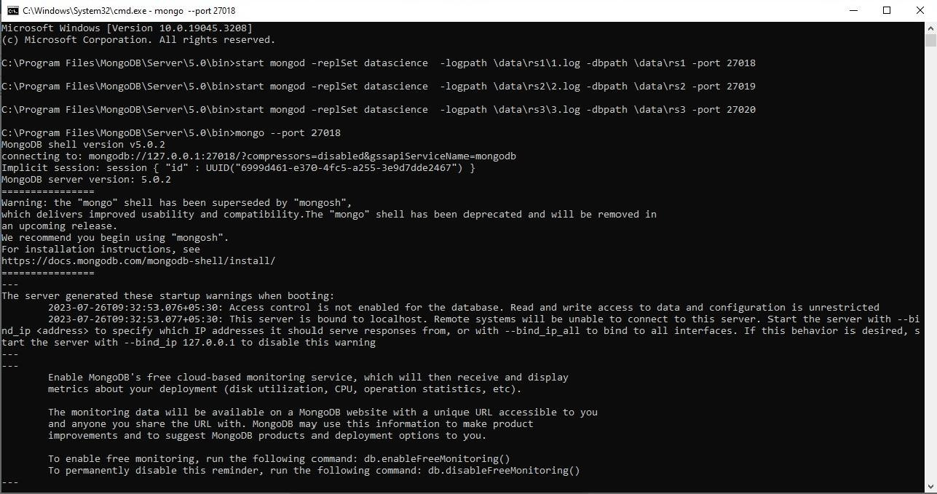

1. 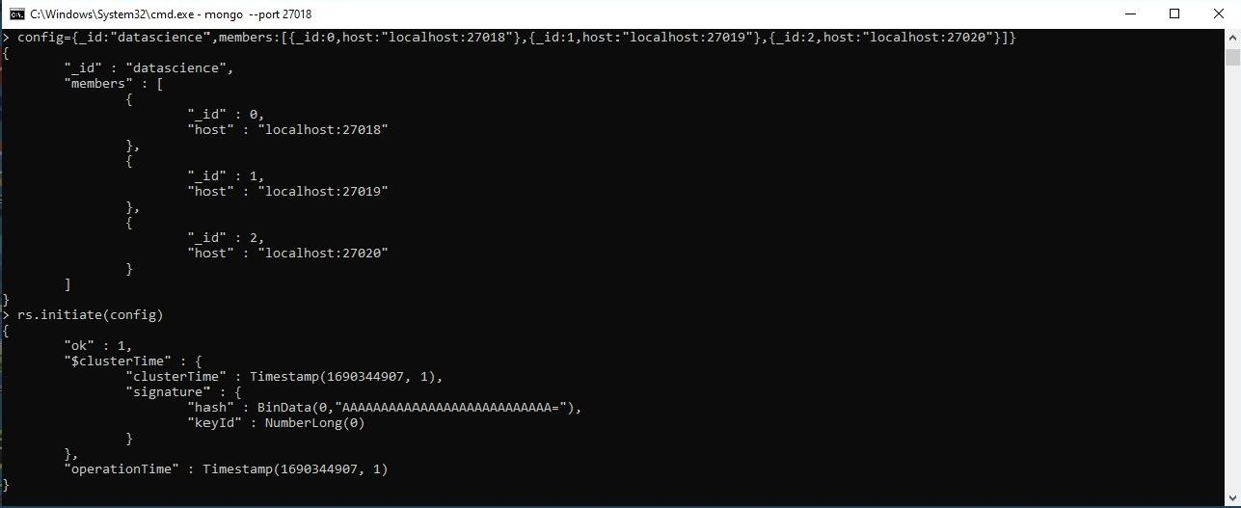Configure Replica Set
2. 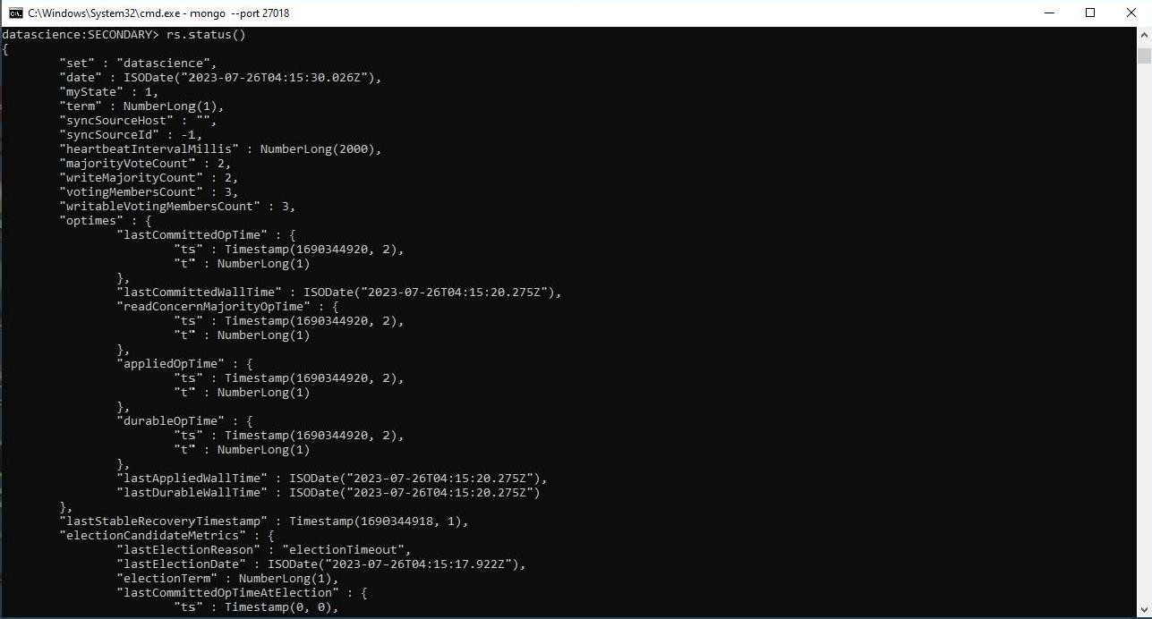Replica Set Status
3. List Replica Set

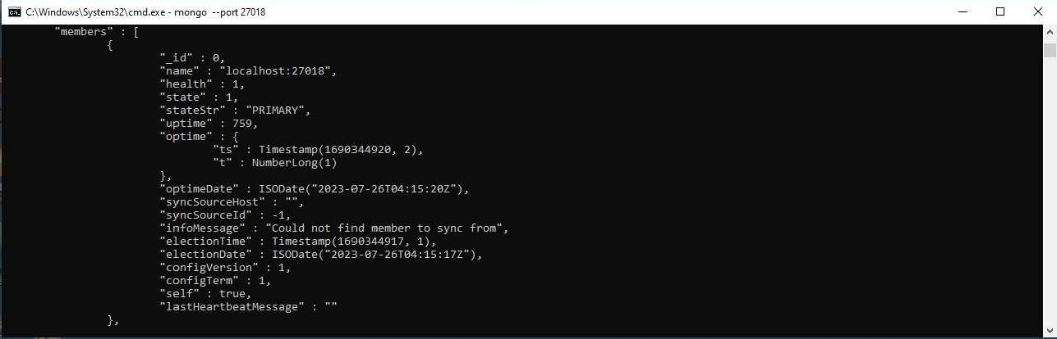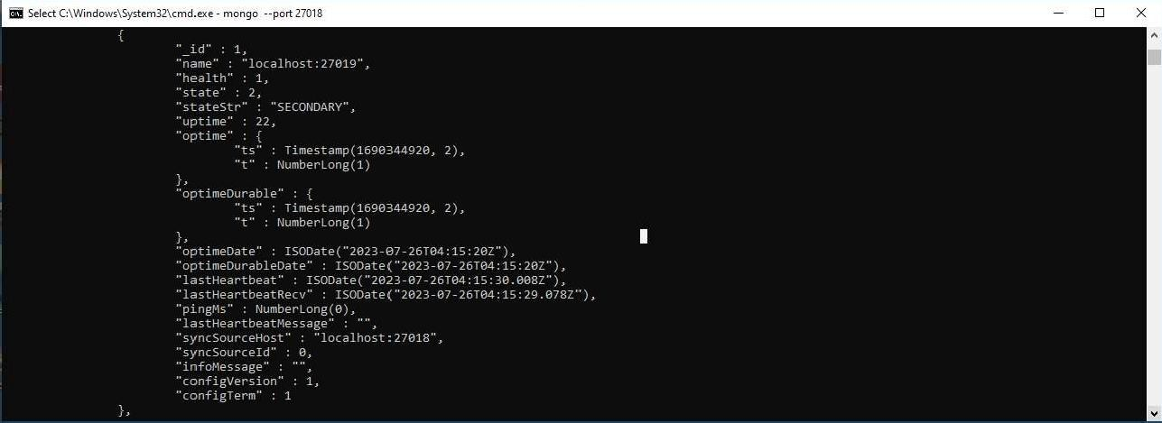

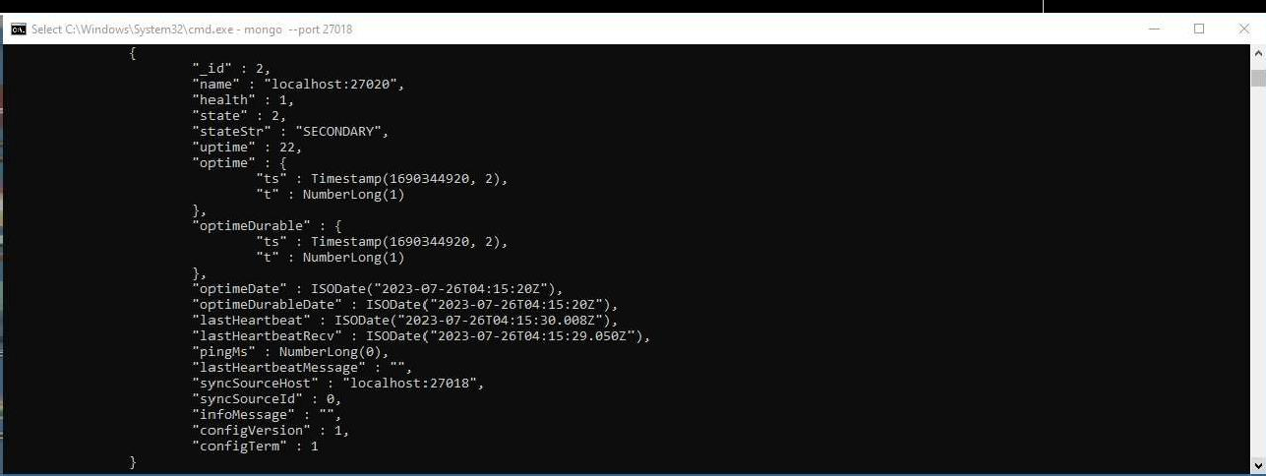

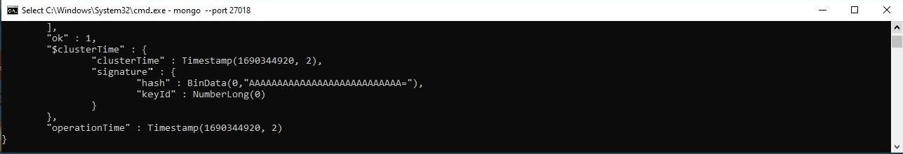

1. Performing operations at Primary

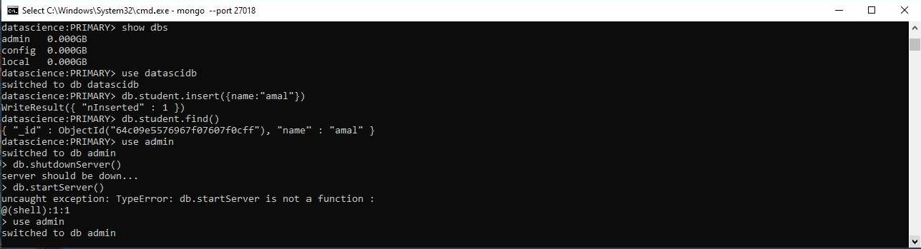

1. Performing operations at Secondary

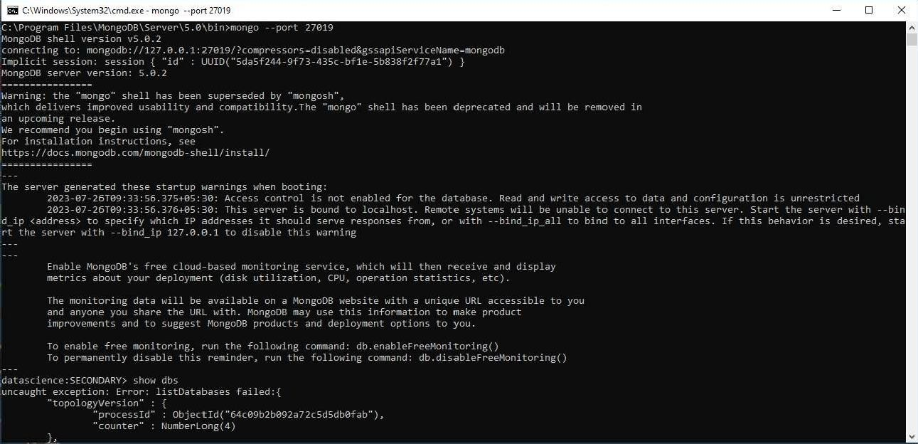

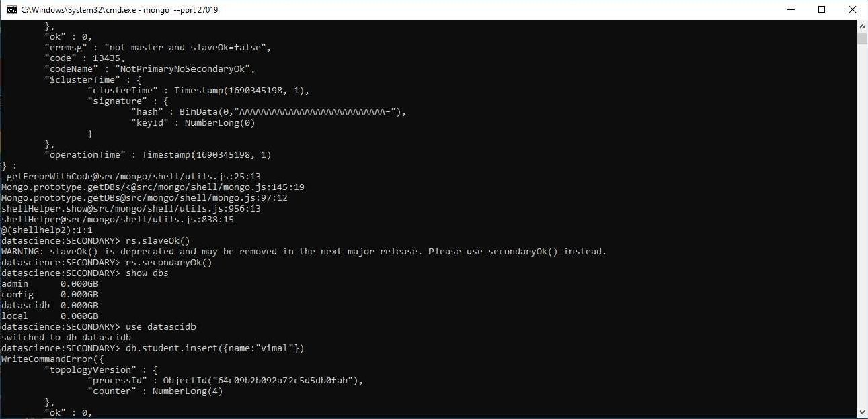

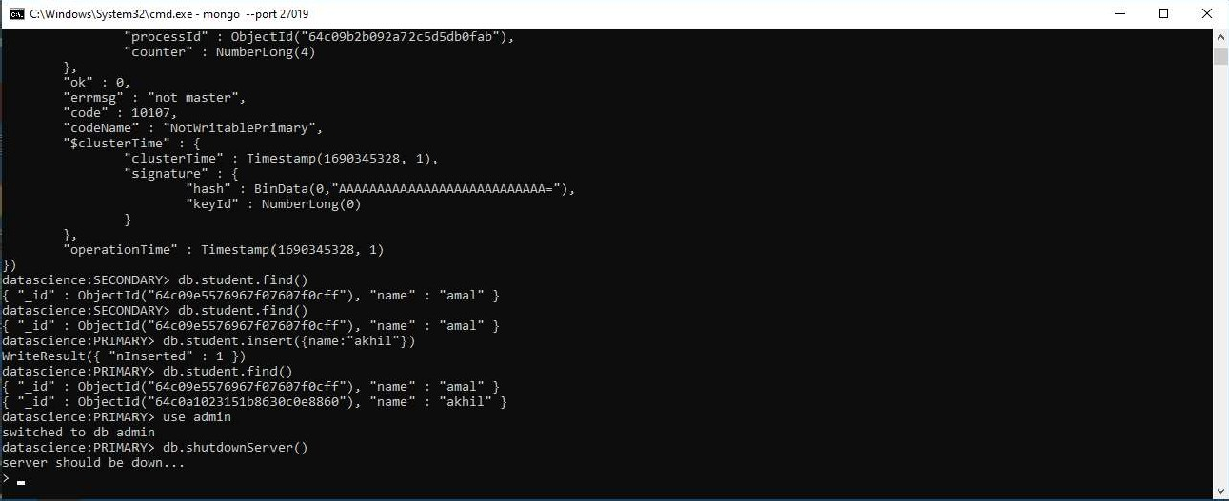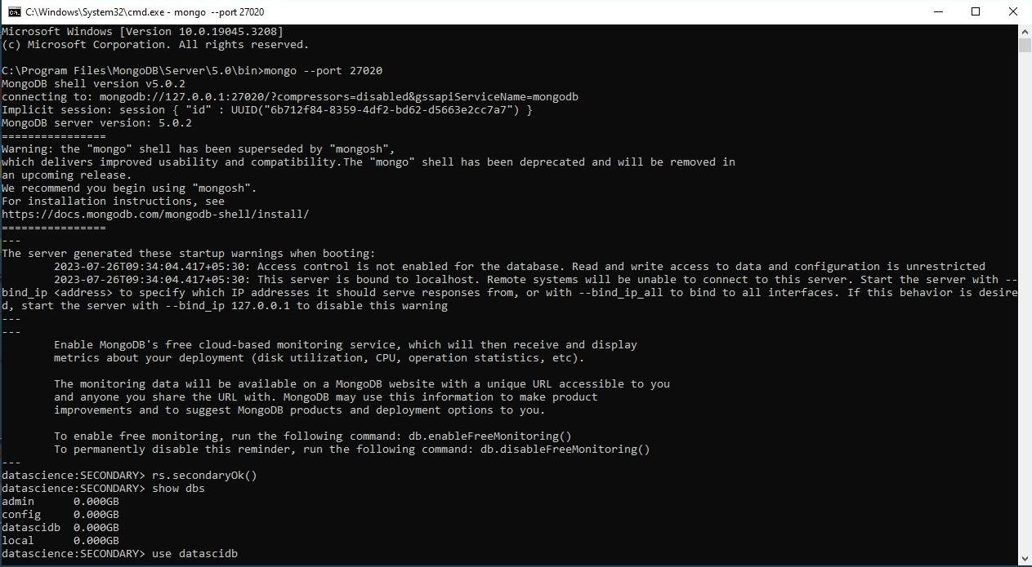

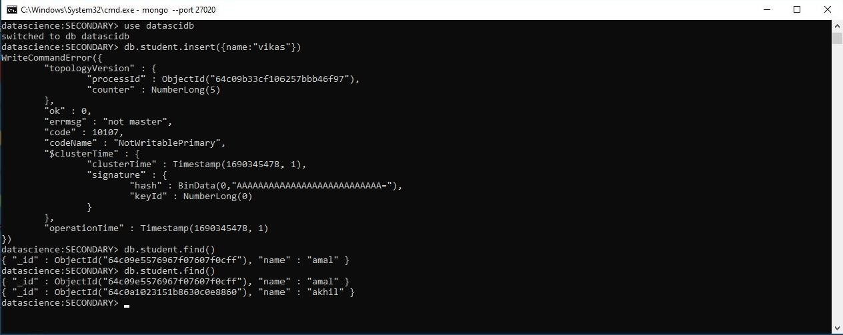

# Result

The program was executed and the result was successfully obtained. Thus CO5 was obtained